**Transfer Learning-based**

**Pneumonia Detection Using Chest X-Ray Images**

**Submitted By**

|  |  |
| --- | --- |
| Saranya Bhattacharjee | University Roll No. 12019009001311 |
| Aditya Jaiswal | University Roll No. 12019009023073 |
| Nisha Kumari | University Roll No.12019009023082 |
| Aman Chopra | University Roll No. 12019009022013 |
| Aniket Singh | University Roll No. 12019009022126 |
| Shubham Mukherjee | University Roll No. 12019009001221 |
|  |  |

## Under the guidance of

Prof. Sankhadeep Chatterjee &

Prof. Amartya Chakraborty

Department of Computer Science and Engineering



UNIVERSITY OF ENGINEERING & MANAGEMENT, KOLKATA

University Area, Plot No. III – B/5, New Town, Action Area – III, Kolkata – 700160.

## 

## CERTIFICATE

This is to certify that the project titled “**Transfer Learning-based Pneumonia Detection using Chest X-Ray Images”** submitted by

**SARANYA BHATTACHARJEE (12019009001311),**

**ADITYA JAISWAL (12019009023073)**,

**NISHA KUMARI ( 12019009023082),**

**AMAN CHOPRA (12019009022013)**,

**ANIKET SINGH (12019009022126),**

**SHUBHAM MIKHERJEE (12019009001221)**

students of the UNIVERSITY OF ENGINEERING & MANAGEMENT, KOLKATA, in partial fulfillment of the requirement for the degree of Bachelor of Computer Science Batch 2023, is a bonafide work carried out by them under the supervision and guidance of Prof. Sankhadeep Chatterjee and Prof. Amartya Chakraborty during 6th Semester of the academic session of 2019-2023. The content of this report has not been submitted to any other university or institute. I am glad to inform you that the work is entirely original and its performance is found to be quite satisfactory

.

|  |  |
| --- | --- |
| _______________________________ | _________________________________ |
| Prof. Sankhadeep Chatterjee | Prof. Amartya Chakraborty |

Department of Computer Science & Technology Department of Computer Science & Technology

UEM, Kolkata UEM, Kolkata

________________________

Prof. Sukalyan Goswami

HOD, Department of Computer Science

UEM, Kolkata

## ACKNOWLEDGEMENT

We would like to take this opportunity to thank everyone whose cooperation and encouragement throughout the ongoing course of this project remain invaluable to us.

We are sincerely grateful to our guides Prof. Sankhadeep Chatterjee and Prof. Amartya Chakraborty of the Department of Computer Science, UEM, Kolkata, for their wisdom, guidance, and inspiration helped us to go through with this project and take it to where it stands now.

We would also like to express our sincere gratitude to Prof. Sukalyan Goswami, UEM, Kolkata, and all other departmental faculties for their ever-present assistance and encouragement.

Last but not the least, we would like to extend our warm regards to our families and peers who have kept supporting us and always had faith in our work.

Saranya Bhattacharjee

Aditya Jaiswal

Nisha Kumari

Aman Chopra

Aniket Singh

Shubham Mukherjee

**TABLE OF CONTENTS**

**ABSTRACT........................................................................5**

**CHAPTER – 1: INTRODUCTION...............................................6**

**CHAPTER – 2: LITERATURE SURVEY……………………..7**

**CHAPTER – 3: PROBLEM STATEMENT…………………..8**

**CHAPTER – 4: PROPOSED SOLUTION…………………..9-16**

**CHAPTER – 5: EXPERIMENTAL RESULT ANALYSIS…….17-23**

**CHAPTER – 6: CONCLUSION & FUTURE SCOPE…………..24**

**BIBLIOGRAPHY ..........................................................................25-27**

# ABSTRACT

This study proposes an AI framework for the diagnosis of pediatric pneumonia using chest X-ray images. A convolutional neural network model is constructed to extract features from a given chest X-ray image and classify it to determine if a child is infected with pneumonia or not. Unlike traditional deep learning classification tasks with sufficient image repositories, it is difficult to obtain a large amount of good-quality medical data for pediatric pneumonia classification tasks; therefore, data augmentation algorithms are employed and Transfer Learning approaches are used to improve the validation and classification accuracy of the CNN model. Our proposed study uses different pre-trained network architectures (Resnet50, DenseNet, VGG16, InceptionV3) to reduce computation costs and achieves remarkable Recall (99.23%) and F1 Score (92.53%). Our study aims to ultimately aid in expediting the diagnosis and referral of these treatable conditions, thereby facilitating earlier diagnosis, and resulting in improved clinical outcomes. In short, the key contribution of this work is to provide a CNN-based transfer-learning approach using different pre-trained models to detect pediatric pneumonia and classify bacterial and viral pneumonia with higher accuracy compared to the recent state-of-the-art methods.

# CHAPTER – 1: INTRODUCTION

Pneumonia is considered the greatest cause of child fatalities all over the world. Approximately 1.4 million children die of pneumonia every year, which is 18% of the total children who died at less than five years old [1]. Globally, overall, two billion people are suffering from pneumonia every year [1]. Pneumonia is a lung infection, which can be caused by either bacteria or viruses. Luckily, this bacterial or viral infectious disease can be well treated by antibiotics and antiviral drugs. Nevertheless, faster diagnosis of viral or bacterial pneumonia and the consequent application of correct medication can help significantly to prevent the deterioration of a patient’s condition, which eventually leads to death [2]. Chest X-rays are currently the best method for diagnosing pneumonia [3]. X-ray images of pneumonia are not very clear and are often misclassified to other diseases or other benign abnormalities. Moreover, the bacterial or viral pneumonia images are sometimes miss-classified by the experts, which leads to the wrong medication being given to the patients and thereby worsening their condition of the patients [4–6]. There are considerable subjective inconsistencies in the decisions of radiologists reported in diagnosing pneumonia. There is also a lack of trained radiologists in low-resource countries (LRC), especially in rural areas. Therefore, there is a pressing need for computer-aided diagnosis (CAD) systems, which can help radiologists in detecting different types of pneumonia from chest X-ray images immediately after the acquisition. Currently, many biomedical complications (e.g., brain tumor detection, breast cancer detection, etc.) are using Artificial Intelligence (AI)-based solutions [7–10]. Among the deep learning techniques, convolutional neural networks (CNNs) have shown great promise in image classification and therefore widely adopted by the research community [11]. Deep Learning Machine learning techniques on chest X-rays are gaining popularity as they can be easily used with low-cost imaging techniques and there is an abundance of data available for training different machine-learning models.

Therefore, the motivation of the present study was to utilize the power of machine learning, firstly to diagnose pneumonia by analyzing Chest X-ray images and secondly to differentiate between viral and bacterial pneumonia with better accuracy.

# CHAPTER – 2: LITERATURE SURVEY

Several research groups [1,11, 12, 14,] have reported the use of deep machine learning algorithms in the detection of pneumonia; however, only one article [13] has reported the classification of bacterial and viral pneumonia. There are many works where the authors tried varying the parameters of deep-layered CNN for pneumonia detection. The pattern of diffuse opacification in the lung radiograph due to pneumonia can be alveolar or interstitial. Patients with alveolar infiltration on the chest radiograph, especially those with lobar infiltrates, have laboratory evidence of bacterial infection [15]. Again, interstitial infiltrations on radiographs may be linked with viral pneumonia [16]. These might be the distinctive features of the machine learning algorithms in differentiating viral and bacterial pneumonia. Some researchers have promising results, such as Liang et al. [20], Vikash et al. [17], Krishnan et al. [18], and Xianghong et al. [19]. Some groups have combined CNN with rib suppression and lung filed segmentation for other classification tasks, while some highlighted a visualization technique in CNN to find the region of interest (ROI) that can be used to identify pneumonia and distinguish between bacterial and viral types in pediatric chest X-rays. The concept of transfer learning in the deep learning framework was used by Vikash et al. [17] for the detection of pneumonia using pre-trained ImageNet models and their ensembles. Rajpurkar et al. [21] reported a 121-layer CNN on chest X-rays to detect 14 different pathologies, including pneumonia using an ensemble of different networks. Jung et al. [22] used a 3D Deep CNN with shortcuts and dense connections which help in solving the gradient vanishing problem. Therefore, there is significant room for improving the result either by using different deep learning algorithms or modifying the existing outperforming algorithms, or combining several outperforming algorithms as an ensemble model to produce better classification accuracy, particularly in classifying viral and bacterial pneumonia.

# CHAPTER – 3: PROBLEM STATEMENT

According to the World Health Organization (WHO), pneumonia kills about 2 million children under 5 years old every year and is consistently estimated as the single leading cause of childhood mortality, killing more children than HIV/AIDS, malaria, and measles combined [2]. The WHO reports that nearly all cases (95%) of new-onset childhood clinical pneumonia occur in developing countries, particularly in Southeast Asia and Africa. Bacterial and viral pathogens are the two leading causes of pneumonia [3] but require very different forms of management.

Bacterial pneumonia requires urgent referral for immediate antibiotic treatment, while viral pneumonia is treated with supportive care. Therefore, an accurate and timely diagnosis is imperative. One key element of diagnosis is radiographic data since chest X-rays are routinely obtained as the standard of care and can help differentiate between different types of pneumonia. However, rapid radiologic interpretation of images is not always available, particularly in low-resource settings where childhood pneumonia has the highest incidence and highest rates of mortality.

**Significance and Impact of our work:**

* To quote an example, in Africa’s 57 nations, a gap of 2.3 million doctors and nurses exist. For these populations, an accurate and fast diagnosis means everything. It can guarantee timely access to treatment and save much-needed time and money for those already experiencing poverty
* Potential for generalized high-impact application in biomedical imaging
* The techniques used in the projects could be extended for detecting other lung diseases where X-ray-based detection techniques are currently used
* An ideal example of the same is the currently ongoing research and diagnosis on detecting COVID-19 with Chest X-ray images

## CHAPTER – 4: PROPOSED SOLUTION

**Dataset Description:**

The dataset we used for our classification tasks is taken from Kaggle, created by

Paul Mooney at

(https://www.kaggle.com/paultimothymooney/chest-xray-pneumonia) under Creative Commons License with Attribution 4.0. The data set has three sub-divisions, namely Training, Validation, and Test sets, with sub-categorization for each image category (Pneumonia/Normal). There are a total of 5,856 X-Ray images (JPEG) and 2 categories, namely Pneumonia vs. Normal images. These pediatric chest X-rays of pneumonia patients are further distinguished into viral and bacterial pneumonia to facilitate rapid referrals for children needing urgent intervention.

Salient features under the data collection mechanism:

* Chest X-ray images (anterior-posterior) were selected from retrospective cohorts of pediatric patients one to five years old from Guangzhou Women and Children’s Medical Center, Guangzhou
* All chest X-ray imaging was performed as part of patient's routine clinical care. For the analysis of chest x-ray images, all chest radiographs were initially screened for quality control by removing all low-quality or unreadable scans.
* The diagnoses for the images were then graded by two expert physicians before being cleared for training in the AI system.
* In order to account for any grading errors, the evaluation set was also checked by a third expert.

The data set has the original distribution as mentioned above in table 1.

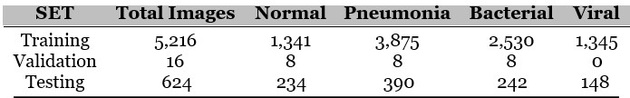

## ● Data subdivision

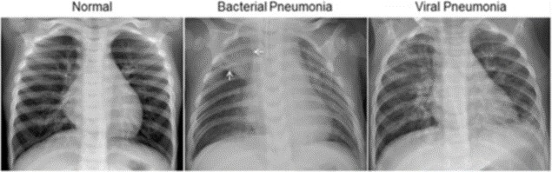

## Figure 1: Sample X-Ray Images under each label

As seen in figure 1, the normal chest X-ray (left panel) depicts clear lungs without any areas of abnormal opacification in the image. Bacterial pneumonia (middle) typically exhibits a focal lobar consolidation, in this case in the right upper lobe (white arrows), whereas viral pneumonia (right) manifests with a more diffuse “interstitial” pattern in both lungs.

**Data Pre-Processing:**

Data Augmentation:

Data Augmentation is a strategy that enables practitioners to significantly increase the diversity of data available for training models by cropping, padding, and horizontally flipping the training data, without actually collecting new data. We have done it using the Image Data Generator class from Keras.

The transformations we have used in our work include Zoom, Horizontal shift, Vertical shift, Horizontal flip, Rotation, and shear.

**Evaluation Criteria:**

From Confusion Matrix:

The confusion matrix evaluates the performance of a supervised classifier using a cross-tabulation of actual and predicted classes. The following evaluation metrics are obtained from the Confusion Matrix, along with Accuracy. We used these to judge the performance of our models.

* Precision is the ratio ( tp / (tp+fp)), where tp is the number of true positives and fp is the number of false positives. Precision intuitively describes the ability of the classifier not to label a false positive as positive.
* Recall is the ratio (tp/ (tp+f n)), where tp is the number of true positives and fn is the number of false negatives. The recall is intuitively the ability of the classifier to identify all the positive samples. Figures 9 and 16 show illustrative visualization of Precision and Recall for various supervised classifiers implemented.
* F1 score can be interpreted as the harmonic mean of Precision and Recall.

2 * (precision * recall) / (precision + recall).

5.2 NLL/Cross-Entropy Loss

The most common loss function used in deep learning networks is Cross-Entropy or in other words, called Negative Log-Likelihood Loss. It is defined as -

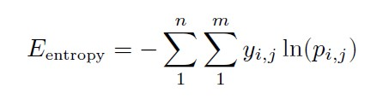

where, yi, j denotes the true value i.e. 1 if sample i belongs to class j and 0

otherwise, and (pi,j) denotes the probability predicted by the model of sample i belonging to class j.

**Methodology/Line of Work:**

The following steps give a broad overview of our work. We have performed 2 kinds of classification - investigating the effectiveness of our CNN and transfer learning architectures in classifying these pediatric chest X-rays to detect Pneumonia vs. Normal Images and furthermore to distinguish viral and bacterial pneumonia.

For both these tasks, we have performed the steps mentioned below, in brief.

* Design Convolutional Neural Network Model and evaluation of results

Use Transfer Learning Approaches for the classification and evaluate various model results

* Comparison of Results and selection the best model based on F1-Score

**1. Convolutional Neural Networks:**

CNNs are proven to have an edge over traditional Neural Networks, where they possess a visual processing scheme that is equivalent to that of humans and an extremely optimized structure for handling images and 2D and 3D shapes, as well as the ability to extract abstract 2D features through learning. The max-pooling layer of the convolutional neural network is effective invariant shape absorptions and comprises sparse connections in conjunction with tied weights.

When compared with fully connected (FC) networks of equivalent size, CNNs have a considerably smaller amount of parameters. Since the gradient-based algorithm is responsible for training the whole network in order to directly diminish an error criterion, highly optimized weights can be produced by CNNs. Apart from the fact that these are computationally expensive, such algorithms like CNN are data-hungry, as in they require huge training samples.

**CNN Model Architecture:**

Figure 2 explains the architecture of the CNN used. The model has 6,638,753 trainable parameters.

**● Description Of Architecture:**

## A. Separable convolution layer

This is a variation of traditional convolution. This performs a depth-wise spatial convolution followed by a point-wise convolution which mixes together the resulting output channels. Separable convolution is computationally faster than traditional convolution. For example, the Mobile net uses a separable convolution layer.

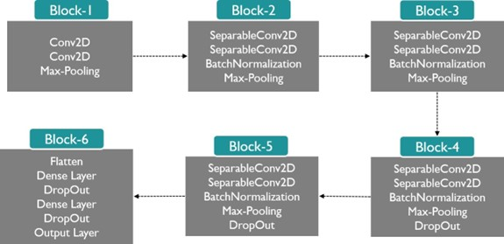

**Figure 2: Brief Architecture of CNN Model**

## B. Padding

Padding is done with zero values such that the dimension remains the same as the image dimension after each convolution.

## C. Batch normalization

Standardization of data is performed as the data passes through each of the layers. So, there will be less oscillation in the cost function. And the optimal solution could be reached faster, by adjusting for the batch sample fluctuations.

**D. Max pooling**

This is used to reduce the number of parameters and computations in the network.

## E. Dropout

This layer is used for regularisation, so that model can be generalizable. Although using more dropout probability makes the model train slow, it avoids over-fitting by making the nodes avoid dependency on specific nodes.

## F. Variable learning rate

When there is no improvement in the evaluation metric, the learning rate will be decreased.

## G. Early stopping

When the generalization gap (i.e. the difference between training and validation error) starts to increase, instead of decreasing training is stopped.

## 2. Transfer Learning

One method of addressing a lack of data in a given domain is to leverage data from a similar domain, a technique known as transfer learning. Transfer learning has proven to be a highly effective technique, particularly when faced with domains with limited data. Rather than training a completely blank network, by using a feed-forward approach to fix the weights in the lower levels already optimized to recognize the structures found in images in general and retraining the weights of the upper levels with backpropagation, the model can recognize the distinguishing features of a specific category of images, like fine fabric-like structures in X-Ray Images, much faster and with significantly fewer training examples and less computational power.

**Brief Description of Architectures:**

## A. ResNet50

The core idea of ResNet is introducing a so-called “identity shortcut connection” that skips one or more layers. The authors of ResNet argue that stacking layers shouldn’t degrade the network performance, because we could simply stack identity mappings (the layer that doesn’t do anything) upon the current network, and the resulting architecture would perform the same. This indicates that the deeper model should not produce a training error higher than its shallower counterparts. They hypothesize that letting the stacked layers fit a residual mapping is easier than letting them directly fit the desired under-laying mapping. Also, the residual block explicitly allows it to do precisely that.

## B. DenseNet

DenseNet(Densely Connected Convolutional Networks) is one of the latest neural networks for visual object recognition. It’s quite similar to ResNet but has some fundamental differences. For each layer, the feature maps of all preceding layers are used as inputs, and its own feature maps are used as inputs into all subsequent layers. DenseNets have several compelling advantages: they alleviate the vanishing gradient problem, strengthen feature propagation, encourage feature reuse, and substantially reduce the number of parameters.

## C. InceptionV3

The Inception Module is based on a pattern recognition network that mimics the animal visual cortex. After presenting several examples of images, the network gets used to small details, middle-sized features, or almost whole images if they come up very often. Using Tensorflow we adapted the InceptionV3 architecture that is pre-trained on the ImageNet data set (Szegedy et al., 2016). Retraining consisted of initializing the convolutional layers with loaded pre-trained weights and retraining the final, softmax layer to recognize our classes from scratch. Briefly, this model attempts to ‘fine-tune’ the convolutional layers by unfreezing and updating the pre-trained weights on our medical images using back-propagation tended to decrease model performance due to over-fitting.

## D. VGG

It makes the improvement over AlexNet by replacing large kernel-sized filters (11 and 5 in the first and second convolutional layer, respectively) with multiple 33 kernel-sized filters one after another. This model architecture has achieved 92.7% top-5 test accuracy on the ImageNet data set which contains 14 million images belonging to 1000 classes and secured top among contenders in the 2014 ILSVRC Visual Recognition Challenge.

## CHAPTER – 5: EXPERIMENTAL RESULT ANALYSIS

### 5.1 Pneumonia vs. Normal Classification

The models are trained until saturation. Table 2 explains the model performance. Plots for Training and Validation Losses by different model tryouts are in Figures 3 to 7. Similarly, plots for Accuracy, F1-Score, Precision, and Recall are in figures 8 and 9.

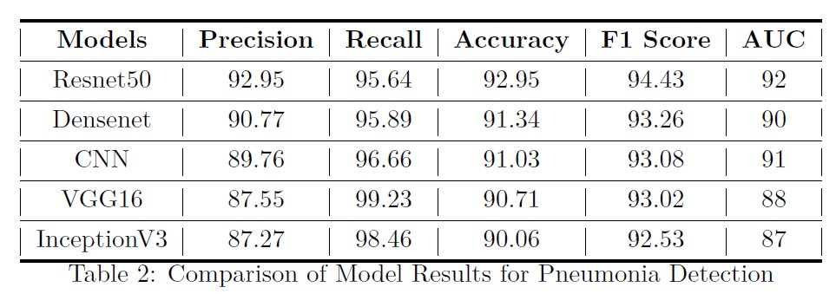

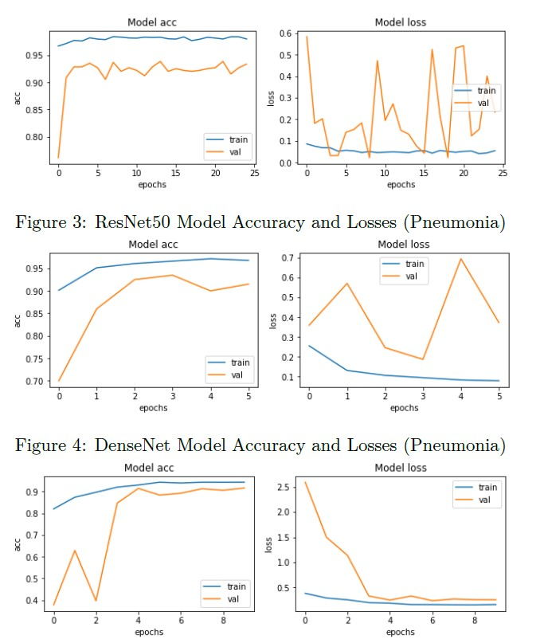



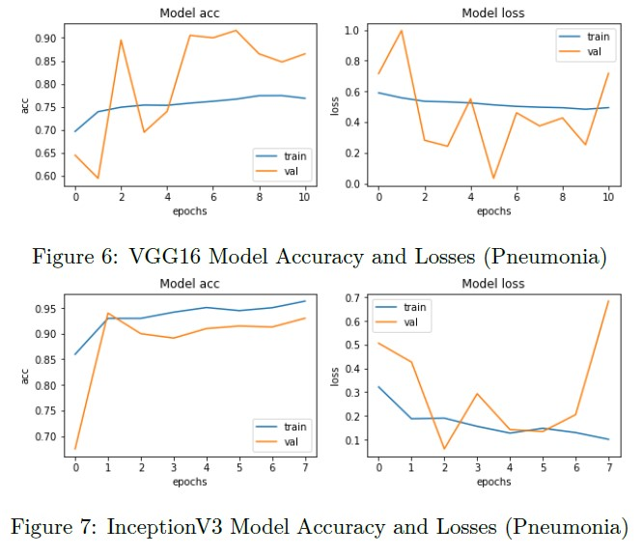

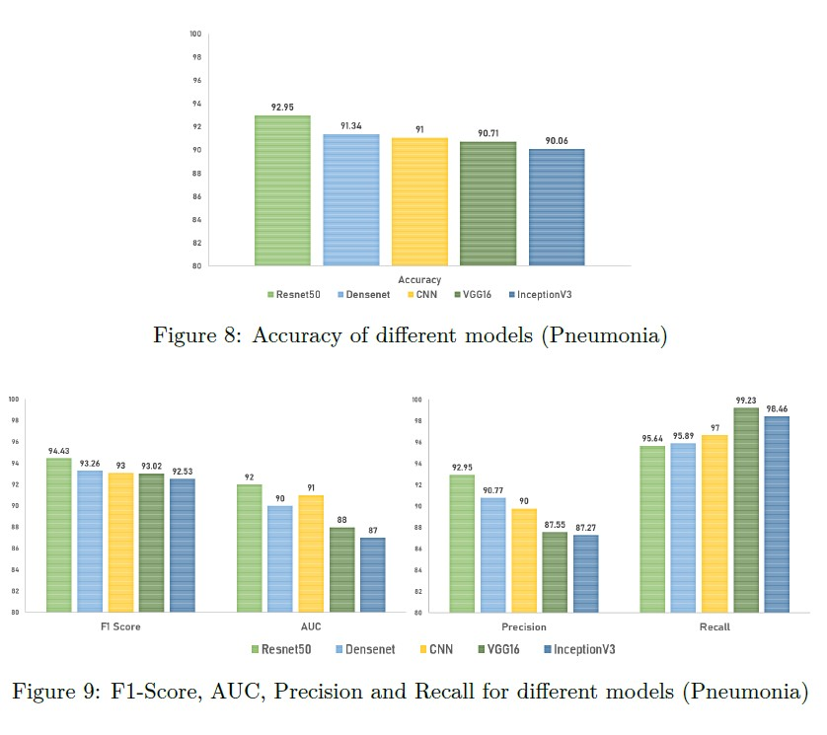

### 5.2 Bacterial vs. Viral Classification

The models are trained until saturation. Table 3 explains the model performance. Plots for Training and Validation Losses and accuracy by different model tryouts are in Figures 10 to 14. Similarly, plots for Accuracy, F1-Score, Precision, and Recall are in figures 15 and 16.

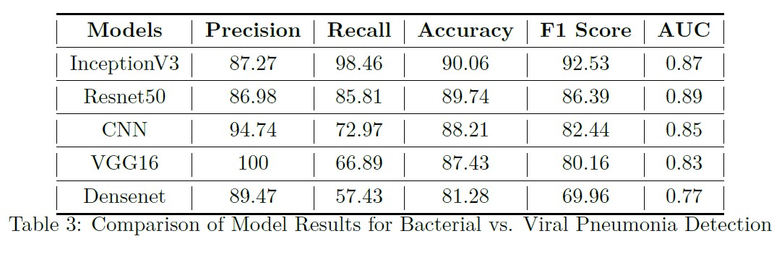

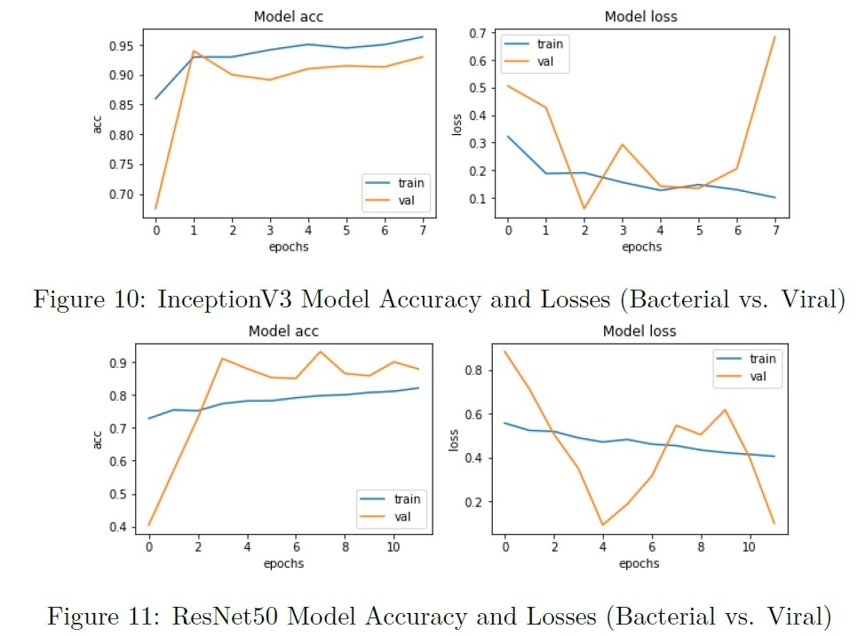

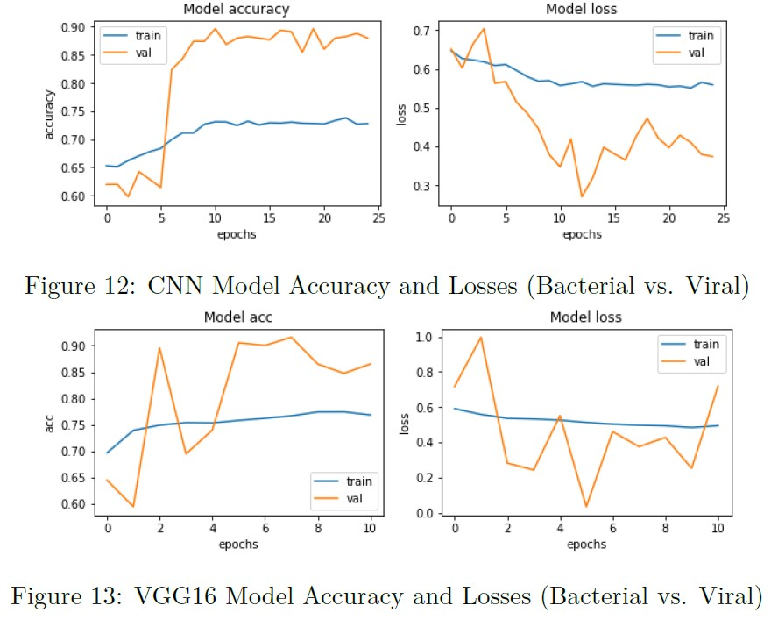

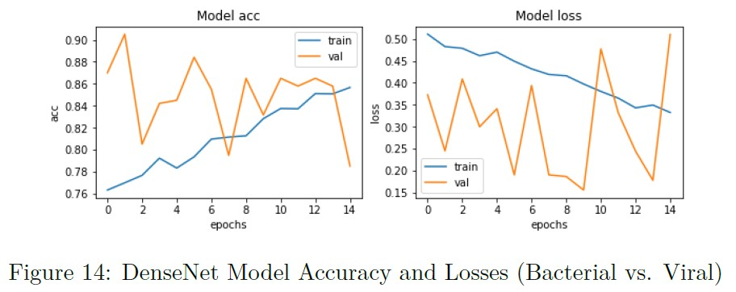

This also means that our model is more generalizable and robust than the existing architectures. We also showcased the power of the transfer learning system to make highly effective classifications, even with a very limited training data set.

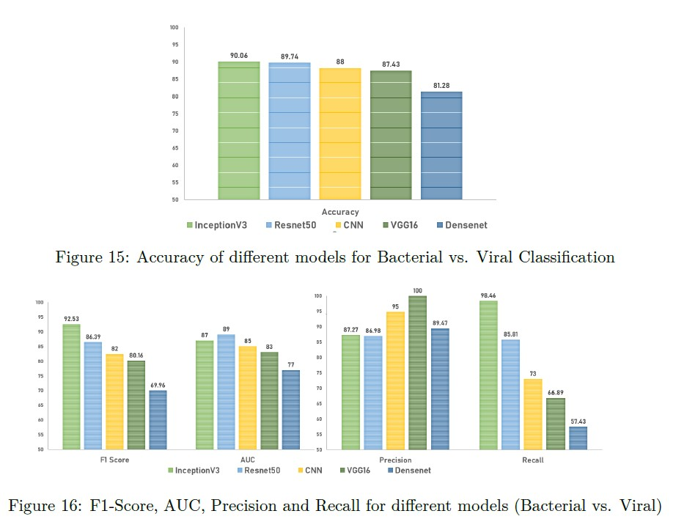

# CHAPTER – 6: CONCLUSION & FUTURE SCOPE

Our study will go on a long way in improving the health of at-risk children in energy-poor environments. As our analysis was limited by the depth of data, increased access to data and training of the model with radiological data from patients and non-patients in different geography can create significant improvements in the model. Hence, future studies could entail the use of images from varied manufacturers, so that the system will be universally useful and acceptable.

In principle, the techniques we have described here could potentially be extended to a wide range of medical images across multiple disciplines such as Ophthalmology, CT Scans, etc. There is also the concept of Occlusion testing to identify areas of greatest importance used by the model while assigning a diagnosis. The greatest benefit of an occlusion test is that it reveals insights into the decisions of neural networks, which are infamously known as ’black boxes with no transparency.

## BIBLIOGRAPHY

1. Imran, A. Training a CNN to detect Pneumonia. 2019. Available online: https://medium.com/datadriveninvestor/training-a-cnn-to-detect-pneumoniac42a44101deb (accessed on 23 October 2022).
2. Aydogdu, M.; Ozyilmaz, E.; Aksoy, H.; Gursel, G.; Ekim, N. Mortality prediction in community-acquired pneumonia requiring mechanical ventilation; values of pneumonia and intensive care unit severity scores. Tuberk Toraks 2010, 58, 25–34.
3. WHO. Standardization of Interpretation of Chest Radiographs for the Diagnosis of Pneumonia in Children; World Health Organization: Geneva, Switzerland, 2001.
4. Neuman, M.I.; Lee, E.Y.; Bixby, S.; DiPerna, S.; Hellinger, J.; Markowitz, R.; Servaes, S.; Monuteaux, M.C.; Shah, S. Variability in the interpretation of chest radiographs for the diagnosis of pneumonia in children. J. Hosp. Med. 2011, 7, 294–298.
5. Dele Davies, H.; Wang, E.E.-L.; Manson, D.; Babyn, P.S.; Shuckett, B. Reliability of the chest radiograph in the diagnosis of lower respiratory infections in young children. Pediatr. Infect. Dis. J. 1996, 15, 600–604.
6. Hopstaken, R.; Witbraad, T.; Van Engelshoven, J.; Dinant, G. Inter-observer variation in the interpretation of chest radiographs for pneumonia in community-acquired lower respiratory tract infections. Clin. Radiol. 2004, 59, 743–752.
7. Tahir, A.M.; Chowdhury, M.E.H.; Khandakar, A.; Al-Hamouz, S.; Abdalla, M.; Awadallah, S.; Reaz, M.B.I.; Al-Emadi, N. A Systematic Approach to the Design and Characterization of a Smart Insole for Detecting Vertical Ground Reaction Force (vGRF) in Gait Analysis. Sensors 2020, 20, 957.
8. Chowdhury, M.E.H.; Alzoubi, K.; Khandakar, A.; Khallifa, R.; Abouhasera, R.; Koubaa, S.; Ahmed, R.; Hasan, A. Wearable Real-Time Heart Attack Detection and Warning System to Reduce Road Accidents. Sensors 2019,

19, 2780.

1. Chowdhury, M.E.H.; Khandakar, A.; Alzoubi, K.; Mansoor, S.; Tahir, A.M.; Reaz, M.B.I.; Al-Emadi, N. Real-Time Smart-Digital Stethoscope System for Heart Diseases Monitoring. Sensors 2019, 19, 2781.
2. Kallianos, K.; Mongan, J.; Antani, S.; Henry, T.; Taylor, A.; Abuya, J.; Kohli, M. How far have we come? Artificial intelligence for chest radiograph interpretation. Clin. Radiol. 2019, 74, 338–345.
3. Wang, X.; Peng, Y.; Lu, L.; Lu, Z.; Bagheri, M.; Summers, R.M. ChestX-ray8: Hospital-Scale Chest X-ray Database and Benchmarks on Weakly-Supervised Classification and Localization of Common Thorax Diseases. In Proceedings of the 2017 IEEE Conference on Computer Vision and Pattern Recognition (CVPR), Honolulu, HI, USA, 21–26 July 2017; pp. 3462–3471.
4. Ronneberger, O.; Fischer, P.; Brox, T. U-Net: Convolutional Networks for Biomedical Image Segmentation. In Proceedings of the Lecture Notes in Computer Science; Springer Science and Business Media LLC: Cham,

Switzerland, 2015; Volume 9351, pp. 234–241.

1. Ho, T.K.K.; Gwak, J. Multiple Feature Integration for Classification of Thoracic Disease in Chest Radiography. Appl. Sci. 2019, 9, 4130.

[CrossRef]

1. Saraiva, A.; Santos, D.; Costa, N.; Sousa, J.; Ferreira, N.; Valente, A.; Soares, S. Models of Learning to Classify X-ray Images for the Detection of Pneumonia using Neural Networks. In Proceedings of the 12th International Joint Conference on Biomedical Engineering Systems and Technologies, Prague, Czech, 22–24 February 2019; pp. 76–83.
2. Virkki, R.; Juvén, T.; Rikalainen, H.; Svedstrom, E.; Mertsola, J.; Ruuskanen, O. Differentiation of bacterial and viral pneumonia in children. Thorax 2002, 57, 438–441.
3. Ishiguro, T.; Kobayashi, Y.; Uozumi, R.; Takata, N.; Takaku, Y.; Kagiyama, N.; Kanauchi, T.; Shimizu, Y.; Takayanagi, N. Viral Pneumonia Requiring

Differentiation from Acute and Progressive Diffuse Interstitial Lung Diseases. Intern. Med. 2019, 58, 3509–3519.

1. Chouhan, V.; Singh, S.K.; Khamparia, A.; Gupta, N.; Tiwari, P.; Moreira, C.; Damasevicius, R.; De Albuquerque, V.H.C. A Novel Transfer Learning Based Approach for Pneumonia Detection in Chest X-ray Images. Appl. Sci. 2020, 10, 559.
2. Rajaraman, S.; Candemir, S.; Kim, I.; Thoma, G.R.; Antani, S. Visualization and Interpretation of Convolutional Neural Network Predictions in Detecting Pneumonia in Pediatric Chest Radiographs. Appl. Sci. 2018, 8, 1715.
3. Gu, X.; Pan, L.; Liang, H.; Yang, R. Classification of Bacterial and Viral Childhood Pneumonia Using Deep Learning in Chest Radiography. In Proceedings of the 3rd international conference on Mobile and ubiquitous multimedia—MUM ’04; Association for Computing Machinery (ACM),

Guiyang China, 16–18 March 2018; pp. 88–93.

1. Liang, G.; Zheng, L. A transfer learning method with deep residual network for pediatric pneumonia diagnosis. Comput. Methods Programs Biomed. 2020, 187, 104964.
2. Rajpurkar, P.; Irvin, J.; Ball, R.L.; Zhu, K.; Yang, B.; Mehta, H.; Duan, T.; Ding, D.; Bagul, A.; Langlotz, C.P.; et al. Deep learning for chest radiograph diagnosis: A retrospective comparison of the CheXNeXt algorithm to practicing radiologists. PLoS Med. 2018, 15, e1002686.
3. Jung, H.; Kim, B.; Lee, I.; Lee, J.; Kang, J. Classification of lung nodules in CT scans using three-dimensional deep convolutional neural networks with a checkpoint ensemble method. BMC Med. Imag. 2018, 18, 48.